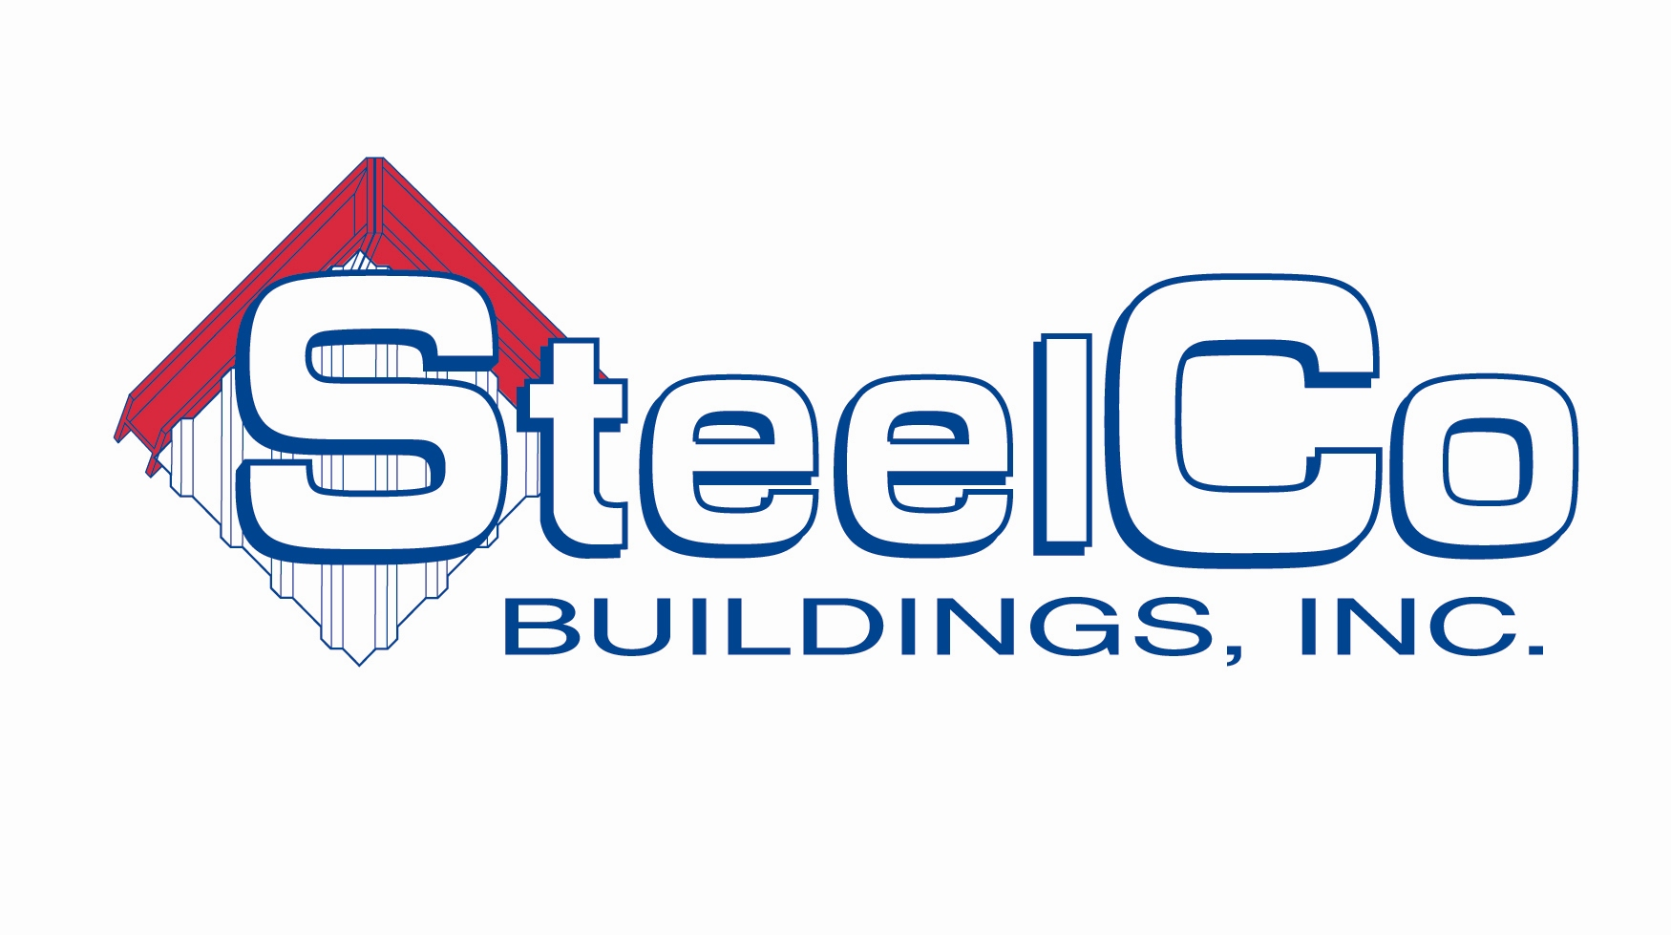
55 Oxford Business Parkway
Covington, GA 30054
Phone: (866)728-9973
Fax: (678) 212 2199
www.steelcobuildings.net

Sales Associate – Job Description

Summary of Position
______________________________________________________________________________________
This is a position within the Sales Department. The overview of a Sales Associate is to sell pre-engineered steel buildings and building components.

Reports to Sales Manager

Duties and Responsibilities

______________________________________________________________________________________

Sell pre-engineered steel buildings
Establishes, develops and maintains business relationships with current SteelCo customers and prospective customers to generate new business for SteelCo
Makes telephone calls and occasional in-person visits to customers
Researches sources for developing prospective customers and for information to determine their potential
Expedites the resolution of customer problems and complaints
Take leads via the internet, phone and networking channels
Meet monthly sales quota and minimum margin requirements
Maintain documentation for job files
Build and maintain customer relationships
Maintain proficiency in various pricing systems for pre-engineered buildings and components
Prioritizes work load/time-investment in order to maximize efficiency
Communicates value-proposition that separates SteelCo from the competitors

Qualifications
______________________________________________________________________________________

Highly motivated self-starter
Exercises good judgment
Quick learner
Good listening skills
Good presentation skills
Phone etiquette
Customer-focused
Goal-oriented
Basic computer skills
Exudes confidence
Ability to recognize buyer signals
Ability to capitalize on sales opportunities
Prospecting skills
Reliable transportation

Negotiation abilities

