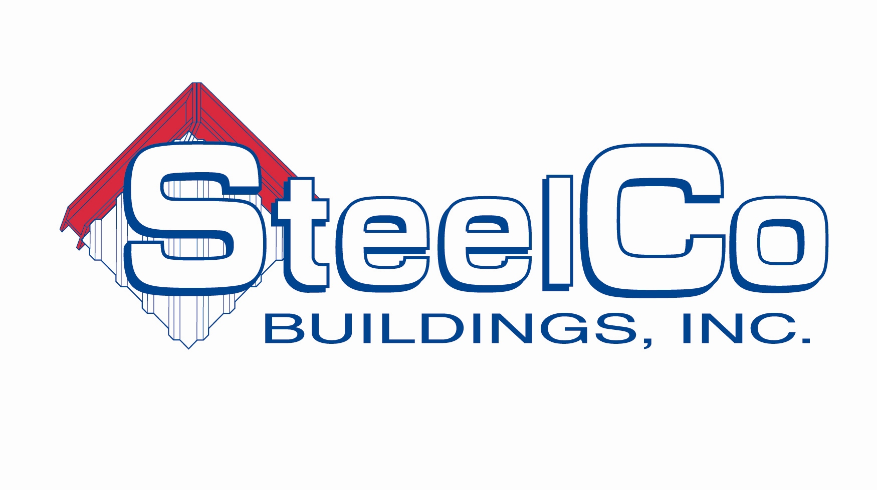
55A Oxford Business Parkway
Covington, GA 30054
Phone: (678)212-2190
Fax: (678) 212-2199
www.steelcobuildings.com

Construction Superintendent – Job Description

Summary of Position
______________________________________________________________________________________
This is a full time position responsible for overseeing all activities of the jobsite, including safety and the management of subcontractor performance.

Reports to VP of Construction

Duties and Responsibilities

______________________________________________________________________________________

Manage and enforce 100% compliance to job site and OSHA safety rules and regulations
Perform weekly tool box talks on job sites and/or ensure all subcontractors are performing them
Manage and coordinate subcontractors on site or multiple sites
Coordinate with project management delivery of materials, schedule of subcontractors, etc..
Active participant in pre-construction, construction, coordination and job site meetings as necessary
Maintain construction journal with safety, progress, delays, projections, weather, change orders and other pertinent project-specific information
Make in-the-field decisions to keep the job moving forward and on schedule
Ensure quality work is completed on time and in budget
Read blueprints and technical documents
On-site liaison between customer and SteelCo management as well as liaison between subcontractors and SteelCo management
Inspections of all activities, pre, during and post completion
Travel to job sites to gather information on materials needed, labor requirements and other factors
Maintain communication with subcontractors and vendors
Travel may be required depending on project location

Qualifications
______________________________________________________________________________________

Bachelor’s degree in industry related field, such as construction management, building science or engineering a plus
Knowledge of OSHA safety regulations
Self-motivated and punctual
Time management skills
Computer skills including Excel, Word and Outlook
Effective verbal and listening skills Effective written communication skills
Organization skills and detail oriented
Honest, respectful and trustworthy
Ability to multi-task and be flexible
Professional appearance and speech
OSHA 30 a plus

Ability to read plans

