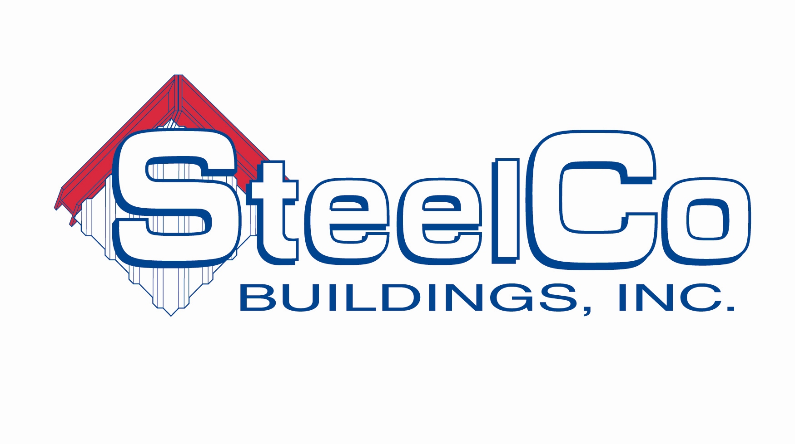

Project Manager – Job Description

Summary of Position
______________________________________________________________________________

This is a full-time position consists of planning, directing, coordinating, or budgeting activities concerned with the construction of commercial general contracting projects. It also consists of participating in the conceptual development of a construction project and overseeing its organization, scheduling, and implementation.

Reports to VP of Construction

Duties and Responsibilities

______________________________________________________________________________

- Confer with construction superintendents, owners, subcontractors and design professionals to discuss and resolve matters such as work procedures, complaints, and construction problems
- Inspect and review projects to monitor compliance with building and safety codes and other regulations
- Interpret and explain plans and contract terms to owner and owner’s representatives
- Prepare and submit budget estimates and progress and cost tracking reports
- Prepare contracts and negotiate revisions, changes, and additions to contractual agreements with architects, clients, suppliers, and subcontractors
- Schedule the project in logical steps and budget time required to meet deadlines
- Study job specifications to determine appropriate construction methods and sequence
- Take actions to deal with the results of delays, bad weather, or emergencies at the construction site

Qualifications
______________________________________________________________________________

- Bachelor’s degree in industry related field, such as construction management, building science, engineering or relevant experience
- Knowledge of cost estimating
- Self-motivated and punctual
- Time management skills
- Computer skills including Excel, Word, Outlook and Primavera SureTrak or Microsoft Project

- Effective verbal and listening skills Effective written communication skills
- Organization skills and detail oriented
- Honest, respectful, and trustworthy
- Ability to multi-task and be flexible
- Professional appearance and speech
- CAD/design software skills a plus

